Good day!
Here are some of the things that need to be improved/concerns from the users of Verdida Sports Apparel Program as of September 30, 2026.

Can we add a Log in to another account option before the Logout?

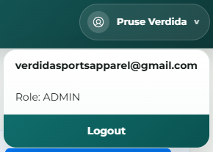

- Dashboard
Make these functional. Connect them to where their information came from.

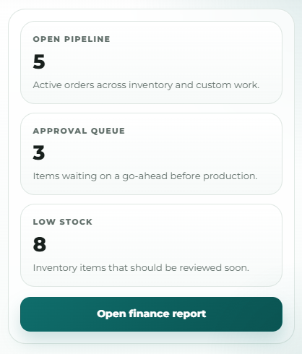

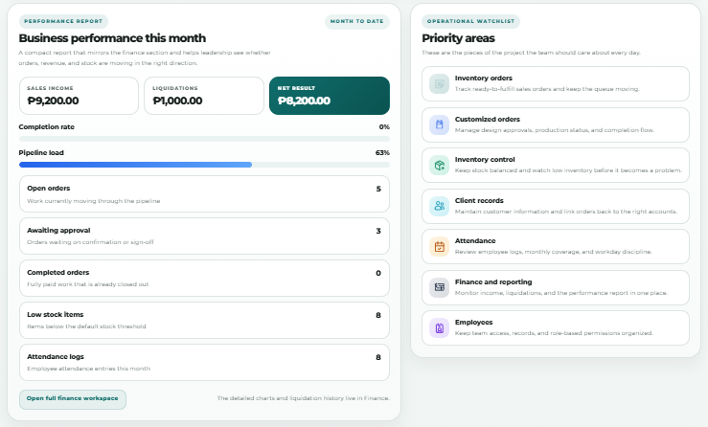

- Inventory Orders and Customized Orders
- We can not use the Returned Orders.
- There is a 100 limit of items in the inventory
- Add a graphic artist part for these portion
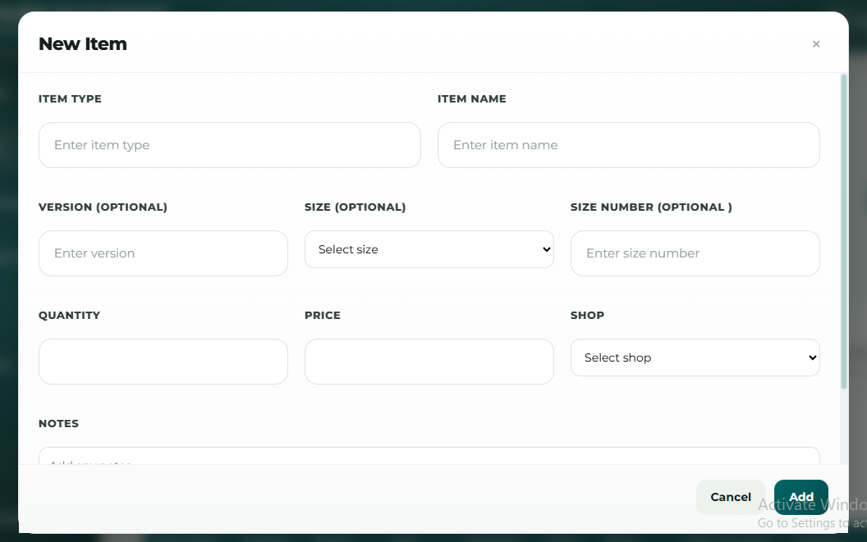
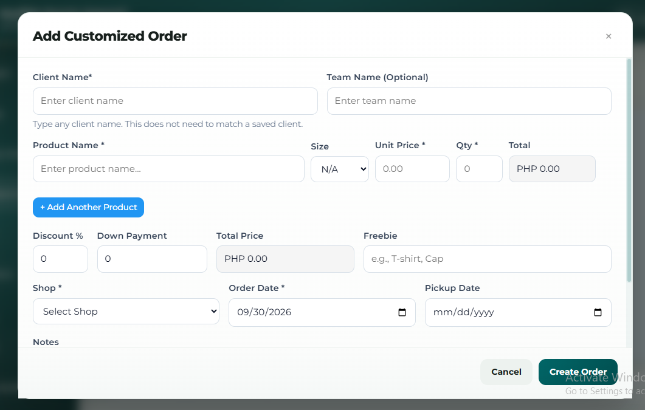

- Clients

- Add the list of orders that this client has been placed (connected to the encoded orders)

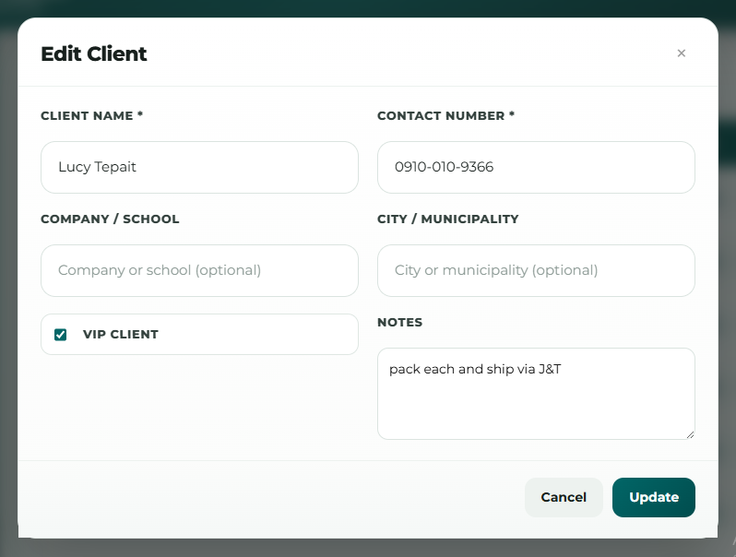

- Finance
- We prefer to see the Team’s Name and Client’s Name in each transaction history
- We cannot edit a client’s payment (if masayup balik sa uno)

- Employees
- Add an Optional Access to the registered employees
- We can add repeated names of employee to the Marketing and Production which is not supposed to be.
- We can’t add an employee to the Graphic Artists and Machine Operators

